



**Cloud Services – Assessment # 7**

Week 7 Time: 3 - Hours

Name: _____________________ Marks: 100

**Q1**.- A Virtual Private Cloud (VPC) is a private and isolated virtual network created on Huawei Cloud. This exercise describes how to create VPCs (basic configurations), configure security groups and network ACLs (security configurations), enable communications between VPCs, and allow Internet access for resources in a VPC (connectivity configurations).

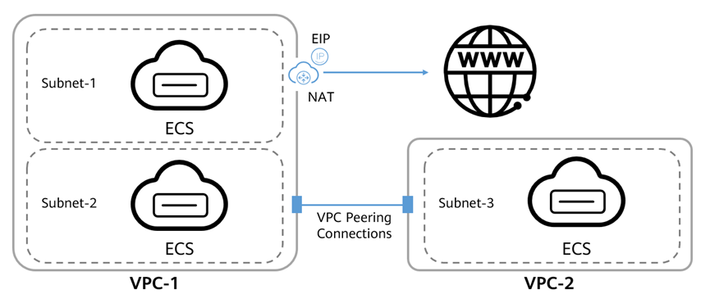

* VPC basic configurations: Create VPCs and subnets.
* VPC security configurations: Configure security groups and network ACLs.
* VPC connectivity configurations:
* Configure a NAT gateway to enable resources in a VPC to access the Internet
* Configure a VPC peering connection to enable communications between two VPCs.